SIMATS ENGINEERING
ASSESSMENT TOOL 1

COURSE NAME: INTERNET PROGRAMMING
COURSE CODE: CSA4307

COURSE OUTCOME COVERED

CO 3: Implement dynamic web applications by utilizing DOM-based client-side scripting and employing Java Servlets for server-side request processing and response handling. (L3)

Assessment Tool : Scenario-Based Assessment

Weightage: 40%
Dr.V.Parthipan

QUESTIONS: Total Marks: 30

Question 1
Suppose that a college wants to develop an online student registration system where students submit their details through a web form, and the data is processed using a Java Servlet.
Explain the architecture of a servlet-based application. Design and implement a servlet to handle form data using both GET and POST methods. Describe the servlet life cycle (init, service, destroy) and justify which method is more appropriate for handling sensitive data.

Question 2
Suppose that a website requires users to log in and maintain their session across multiple pages after authentication.
Design a session management system using HttpSession and Cookies in Servlets. Explain how session tracking works in web applications and compare session-based tracking with cookies.

Question 3
Suppose that an e-commerce platform needs to store and retrieve product details from a database using a Java-based web application. Design a JDBC-based application to connect to a database, insert product data, and retrieve it using SQL queries. Explain the JDBC architecture and describe the steps involved in database connectivity along with proper exception handling.

Code of Conduct:

I M. ATCHAYA (192411088) (Name / Reg No) certify that this submission is my original work and that I have adhered to the guidelines specified for this assessment.
I understand that any violation of academic integrity rules will result in disciplinary action.

Signature of the student:

RUBRICS FOR CALCULATION:

Criteria | Weightage (%) | Level 4 (Exemplary) | Level 3 (Proficient) | Level 2 (Developing) | Level 1 (Beginning)
Understanding of Scenario | 20% | Demonstrates clear and complete understanding of the scenario and context | Shows good understanding with minor gaps | Partial understanding; misses key aspects | Misinterprets or fails to understand the scenario
Identification of Key Issues | 20% | Accurately identifies all relevant issues and factors involved | Identifies most key issues with minor omissions | Identifies limited issues; some irrelevant points | Unable to identify key issues
Application of Concepts | 25% | Applies appropriate concepts effectively to address the scenario | Applies concepts with minor errors | Limited or partially correct application | Unable to apply relevant concepts
Decision Making | 20% | Makes well-reasoned, logical decisions with strong rationale | Makes reasonable decisions with some justification | Makes weak decisions with limited justification | No clear decisions made or rationale provided
Clarity of Response | 15% | Response is clear, structured, and logically presented | Generally clear with minor issues | Somewhat unclear or poorly structured | Disorganized and difficult to understand

ANSWERS

Question 1: The Front Door (Servlet-Based Registration)

1.1 Understanding the Scenario
Sunrise College wants students to fill a web form (name, email, course, password) and have a Java Servlet process it on the server. Key issues identified:
- The browser and server speak HTTP, so every submission is a request and a response.
- The data must be received, validated and acknowledged.
- The form can be sent with GET or POST, and the choice affects security.
- The servlet must be efficient for hundreds of students registering at once (threading, life cycle).

1.2 Architecture of a Servlet-Based Application
A servlet is a Java class that runs inside a servlet container (for example Apache Tomcat). The container manages the servlet, so the developer never writes main() or opens server sockets.
+-----------+ 1. HTTP Request +--------------------------------------+
| Browser | -------------------> | WEB SERVER / CONTAINER |
| (Client) | | +--------------------------------+ |
| HTML Form| | | Web Container (Tomcat) | |
| | <------------------- | | - maps URL to servlet | |
+-----------+ 5. HTTP Response | | - creates request/response | |
| | - manages threads, lifecycle | |
| +---------------+----------------+ |
| 2. calls | 4. returns |
| v |
| +--------------------+ |
| | RegisterServlet | |
| | doGet() / doPost() | |
| +---------+----------+ |
+------------------|--------------------+
3. (optional) v
Database / Other Resources
Request flow in plain steps:
- The student fills the form and clicks Submit; the browser sends an HTTP request.
- The container reads the URL and finds the matching servlet (via @WebServlet or web.xml).
- The container creates HttpServletRequest and HttpServletResponse objects and calls the servlet's service() method.
- service() routes to doGet() or doPost().
- The servlet builds the response (HTML) and the container sends it back.
Key components: Client (browser), Web Server/Container, Servlet (business logic), Deployment descriptor (web.xml) or annotations, and the Request/Response objects.

1.3 Design and Implementation

Step 1: The HTML form (register.html)
<!DOCTYPE html>
<html>
<head><title>EduGate Registration</title></head>
<body>
<h2>Sunrise College: Student Registration</h2>
<!-- POST version: safe for sensitive data -->
<form action="register" method="post">
Name: <input type="text" name="name" required><br>
Email: <input type="email" name="email" required><br>
Course: <select name="course">
<option>B.Tech CSE</option>
<option>B.Tech IT</option>
<option>MCA</option>
</select><br>
Password: <input type="password" name="password" required><br>
<input type="submit" value="Register (POST)">
</form>
<hr>
<!-- GET version: only for non-sensitive lookups -->
<form action="register" method="get">
Check status by Email: <input type="email" name="email">
<input type="submit" value="Check Status (GET)">
</form>
</body>
</html>

Step 2: The servlet (RegisterServlet.java)
import java.io.IOException;
import java.io.PrintWriter;
import javax.servlet.ServletException;
import javax.servlet.annotation.WebServlet;
import javax.servlet.http.*;
@WebServlet("/register")
public class RegisterServlet extends HttpServlet {
// Called ONCE when the servlet is first loaded
@Override
public void init() throws ServletException {
log("RegisterServlet initialised: ready to accept registrations");
}
// GET: data arrives in the URL (visible), used for read-only requests
@Override
protected void doGet(HttpServletRequest req, HttpServletResponse resp)
throws ServletException, IOException {
resp.setContentType("text/html;charset=UTF-8");
String email = req.getParameter("email");
try (PrintWriter out = resp.getWriter()) {
out.println("<h3>Status check (GET)</h3>");
out.println("<p>Looking up registration for: " + escape(email) + "</p>");
}
}
// POST: data arrives in the request BODY (not shown in URL)
@Override
protected void doPost(HttpServletRequest req, HttpServletResponse resp)
throws ServletException, IOException {
resp.setContentType("text/html;charset=UTF-8");
String name = req.getParameter("name");
String email = req.getParameter("email");
String course = req.getParameter("course");
String password = req.getParameter("password");
try (PrintWriter out = resp.getWriter()) {
if (name == null || name.isBlank() || password == null || password.length() < 6) {
resp.setStatus(HttpServletResponse.SC_BAD_REQUEST);
out.println("<p style='color:red'>Invalid input. Password must be 6+ characters.</p>");
return;
}
out.println("<h2>Welcome to Sunrise College, " + escape(name) + "!</h2>");
out.println("<p>Email: " + escape(email) + "<br>Course: " + escape(course) + "</p>");
// (In Question 3 this data is saved to the database with JDBC)
}
}
// Called ONCE when the servlet is removed or the server stops
@Override
public void destroy() {
log("RegisterServlet destroyed: releasing resources");
}
// Simple XSS protection: never echo raw user input
private String escape(String s) {
if (s == null) return "";
return s.replace("&", "&amp;").replace("<", "&lt;")
.replace(">", "&gt;").replace("\"", "&quot;");
}
}
Note: the code uses javax.servlet (Tomcat 9 and earlier). For Tomcat 10+, replace it with jakarta.servlet.

1.4 Servlet Life Cycle
Load class -> Instantiate -> init() -> service() [repeats per request] -> destroy() -> Garbage collected
| | |
once only doGet / doPost once only
Phase | Method | When it runs | Typical use
Birth | init() | Once, on first request or server start | Open DB connection pool, read config
Life | service() | For every request, in a separate thread | Dispatches to doGet(), doPost() etc.
Death | destroy() | Once, before unloading | Close connections, save state
Important point: only one instance of the servlet exists. The container creates a new thread per request, so instance variables are shared and must be handled in a thread-safe way.

1.5 GET vs POST: A Justified Decision
Feature | GET | POST
Data location | URL query string | Request body
Visible in browser/URL | Yes | No
Stored in history, server logs, bookmarks | Yes | No (body is not logged by default)
Size limit | About 2 KB (browser dependent) | Practically unlimited
Idempotent / cacheable | Yes | No
Best for | Searching, reading, filtering | Registration, login, payments, file upload
Decision: POST is the correct choice for sensitive data.
- With GET, the line /register?email=a@b.com&password=secret123 is visible on screen, saved in browser history, proxy logs and server logs, and leaks through the Referer header.
- POST keeps the password in the request body.
- POST is the right verb for creating data (a registration changes server state), while GET must be safe and repeatable.
- Caveat: POST alone does not encrypt anything. Real security needs HTTPS/TLS, password hashing (BCrypt) on the server, and input validation.

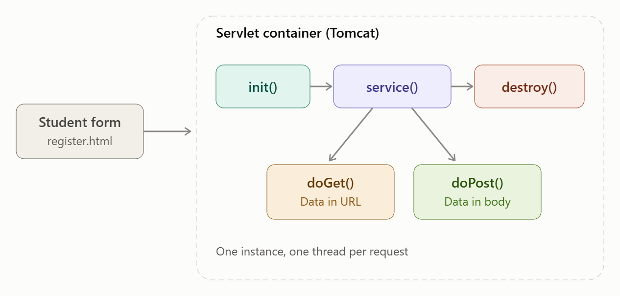

Question 2: The Memory (Session Management)

2.1 Understanding the Scenario
HTTP is stateless: after each response the server forgets the client. Once a student logs in to EduGate, the portal must still recognise them on the dashboard, results and fee pages without asking for a password every time.
Key issues: identifying the same user across requests, protecting against session hijacking and fixation, timing out idle users, handling logout cleanly, and the optional "Remember me" feature.

2.2 How Session Tracking Works
Browser Server
| -- POST /login (user, pass) ----------> | verify credentials
| | create HttpSession, ID = A1B2C3
| <-- Set-Cookie: JSESSIONID=A1B2C3 ----- | store user data on server
| |
| -- GET /dashboard Cookie: A1B2C3 ---> | look up session A1B2C3
| <-- "Welcome back, Asha!" ------------- | found, so user is known
| |
| -- GET /logout ------------------------> | session.invalidate()
Four classic tracking techniques:
- Cookies: small text files stored in the browser and sent with each request.
- HttpSession: the server stores the data and gives the client only a session ID (usually carried in a cookie).
- URL rewriting: the session ID is appended to links (;jsessionid=...) for browsers with cookies disabled.
- Hidden form fields: the ID or state is embedded in forms (works only on form-based flows).

2.3 Design and Implementation

Login servlet
@WebServlet("/login")
public class LoginServlet extends HttpServlet {
@Override
protected void doPost(HttpServletRequest req, HttpServletResponse resp)
throws ServletException, IOException {
String user = req.getParameter("username");
String pass = req.getParameter("password");
boolean remember = "on".equals(req.getParameter("remember"));
if (isValid(user, pass)) { // check against DB (see Question 3)
// 1. Prevent session fixation: discard any old session
HttpSession old = req.getSession(false);
if (old != null) old.invalidate();
// 2. Create a fresh session
HttpSession session = req.getSession(true);
session.setAttribute("user", user);
session.setAttribute("loginTime", System.currentTimeMillis());
session.setMaxInactiveInterval(15 * 60); // 15 minutes idle timeout
// 3. Optional "Remember me" cookie (convenience only, never the password)
if (remember) {
Cookie c = new Cookie("rememberedUser", user);
c.setMaxAge(7 * 24 * 60 * 60); // 7 days (persistent cookie)
c.setHttpOnly(true); // JavaScript cannot read it
c.setSecure(true); // sent over HTTPS only
c.setPath("/");
resp.addCookie(c);
}
resp.sendRedirect("dashboard");
} else {
resp.sendRedirect("login.html?error=1");
}
}
private boolean isValid(String u, String p) { // demo only
return "asha".equals(u) && "edu@123".equals(p);
}
}

Protected page (DashboardServlet)
@WebServlet("/dashboard")
public class DashboardServlet extends HttpServlet {
@Override
protected void doGet(HttpServletRequest req, HttpServletResponse resp)
throws ServletException, IOException {
HttpSession session = req.getSession(false); // false = do NOT create a new one
if (session == null || session.getAttribute("user") == null) {
resp.sendRedirect("login.html"); // not logged in
return;
}
resp.setContentType("text/html");
resp.setHeader("Cache-Control", "no-store"); // stop Back-button viewing after logout
try (PrintWriter out = resp.getWriter()) {
out.println("<h2>Welcome back, " + session.getAttribute("user") + "!</h2>");
out.println("<a href='logout'>Logout</a>");
}
}
}

Logout servlet
@WebServlet("/logout")
public class LogoutServlet extends HttpServlet {
@Override
protected void doGet(HttpServletRequest req, HttpServletResponse resp) throws IOException {
HttpSession session = req.getSession(false);
if (session != null) session.invalidate(); // destroy server-side data
Cookie c = new Cookie("rememberedUser", ""); // delete the cookie
c.setMaxAge(0);
c.setPath("/");
resp.addCookie(c);
resp.sendRedirect("login.html");
}
}

2.4 Session-Based Tracking vs Cookies
Technical note: an HttpSession normally uses a cookie (JSESSIONID) to carry its ID, so the two work together. The real comparison is where the data lives.
Aspect | HttpSession | Cookies
Data stored | On the server | On the client browser
What the client holds | Only a session ID | The actual data
Security | Higher (data hidden from user) | Lower (user can view or edit)
Data type | Any Java object | Text only (String, about 4 KB)
Lifetime | Until timeout or logout (default about 30 min) | Chosen by setMaxAge(), can last days
Survives browser close | No (session cookie is deleted) | Yes, if persistent
Server memory use | Yes, grows with users | None
Scalability | Needs sticky sessions or shared store (Redis) for clusters | Easy, stateless server
Best for | Login state, shopping cart, user profile | Preferences, language, "Remember me", analytics

2.5 Design Decision
- Authentication state goes in HttpSession. A user must not be able to forge "I am the admin" by editing a cookie.
- Cookies carry only low-risk convenience data (theme, language, remembered username).
- Security hardening: regenerate the session on login, set HttpOnly and Secure flags, use a short idle timeout, invalidate on logout, and always serve over HTTPS.

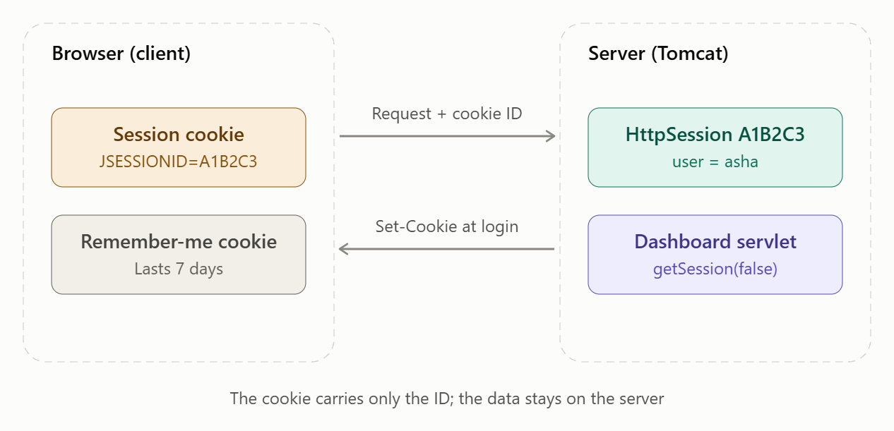

Question 3: The Vault (JDBC Product Store)

3.1 Understanding the Scenario
"ShopSphere", an e-commerce platform, needs to permanently store products (id, name, category, price, stock) and fetch them for display. Data held in memory disappears on restart, so a database is required, and Java reaches it through JDBC (Java Database Connectivity).
Key issues: choosing the right driver, safe SQL (preventing SQL injection), resource leaks (unclosed connections), error handling, and avoiding hard-coded credentials.

3.2 JDBC Architecture
+---------------------------+
| Java Application | (Servlet / Console / Spring)
+-------------+-------------+
| JDBC API (java.sql: Connection, Statement, ResultSet)
+-------------v-------------+
| JDBC Driver Manager | chooses the correct driver for the URL
+-------------+-------------+
| JDBC Driver API
+-------------v-------------+
| JDBC Driver | (MySQL Connector/J, PostgreSQL, Oracle ...)
+-------------+-------------+
| database protocol
+-------------v-------------+
| Database (MySQL) |
+---------------------------+
Core interfaces: DriverManager, Connection, Statement, PreparedStatement, ResultSet, SQLException.
Driver types: Type 1 (JDBC-ODBC bridge, obsolete), Type 2 (native API), Type 3 (network protocol), Type 4 (pure Java, thin driver, the one used today).

3.3 Steps of Database Connectivity
- Load/register the driver: Class.forName("com.mysql.cj.jdbc.Driver") (automatic in JDBC 4+ when the JAR is on the classpath).
- Establish the connection: DriverManager.getConnection(url, user, password).
- Create a statement: PreparedStatement for parameterised SQL.
- Execute the query: executeUpdate() for INSERT/UPDATE/DELETE, executeQuery() for SELECT.
- Process the results: loop through the ResultSet with next().
- Close resources: ResultSet, Statement, Connection, in a finally block or with try-with-resources.

3.4 Database Design
CREATE DATABASE shopsphere;
USE shopsphere;
CREATE TABLE product (
id INT PRIMARY KEY AUTO_INCREMENT,
name VARCHAR(100) NOT NULL,
category VARCHAR(50),
price DECIMAL(10,2) NOT NULL CHECK (price >= 0),
stock INT DEFAULT 0
);

3.5 Implementation

Model class
public class Product {
private int id;
private String name, category;
private double price;
private int stock;
public Product(int id, String name, String category, double price, int stock) {
this.id = id; this.name = name; this.category = category;
this.price = price; this.stock = stock;
}
// getters and toString()
@Override public String toString() {
return id + " | " + name + " | " + category + " | Rs." + price + " | stock: " + stock;
}
}

Data Access class with exception handling
import java.sql.*;
import java.util.*;
public class ProductDAO {
private static final String URL = "jdbc:mysql://localhost:3306/shopsphere";
private static final String USER = "root";
private static final String PASS = System.getenv("DB_PASSWORD"); // never hard-code secrets
private Connection getConnection() throws SQLException {
return DriverManager.getConnection(URL, USER, PASS);
}
// INSERT
public boolean addProduct(String name, String category, double price, int stock) {
String sql = "INSERT INTO product(name, category, price, stock) VALUES (?, ?, ?, ?)";
try (Connection con = getConnection();
PreparedStatement ps = con.prepareStatement(sql)) {
ps.setString(1, name);
ps.setString(2, category);
ps.setDouble(3, price);
ps.setInt(4, stock);
return ps.executeUpdate() > 0;
} catch (SQLIntegrityConstraintViolationException e) {
System.err.println("Constraint violated: " + e.getMessage());
} catch (SQLException e) {
System.err.println("DB error [" + e.getSQLState() + " / " + e.getErrorCode() + "]: " + e.getMessage());
}
return false;
}
// SELECT all
public List<Product> getAllProducts() {
List<Product> list = new ArrayList<>();
String sql = "SELECT id, name, category, price, stock FROM product ORDER BY name";
try (Connection con = getConnection();
PreparedStatement ps = con.prepareStatement(sql);
ResultSet rs = ps.executeQuery()) {
while (rs.next()) {
list.add(new Product(rs.getInt("id"), rs.getString("name"),
rs.getString("category"), rs.getDouble("price"), rs.getInt("stock")));
}
} catch (SQLException e) {
System.err.println("Could not read products: " + e.getMessage());
}
return list;
}
// SELECT with filter (safe from SQL injection)
public List<Product> searchByCategory(String category) {
List<Product> list = new ArrayList<>();
String sql = "SELECT * FROM product WHERE category = ?";
try (Connection con = getConnection();
PreparedStatement ps = con.prepareStatement(sql)) {
ps.setString(1, category);
try (ResultSet rs = ps.executeQuery()) {
while (rs.next()) {
list.add(new Product(rs.getInt("id"), rs.getString("name"),
rs.getString("category"), rs.getDouble("price"), rs.getInt("stock")));
}
}
} catch (SQLException e) {
System.err.println("Search failed: " + e.getMessage());
}
return list;
}
}

Driver program
public class Main {
public static void main(String[] args) {
ProductDAO dao = new ProductDAO();
dao.addProduct("Wireless Mouse", "Electronics", 799.00, 50);
dao.addProduct("Notebook A5", "Stationery", 60.00, 300);
System.out.println("--- All Products ---");
dao.getAllProducts().forEach(System.out::println);
System.out.println("--- Electronics ---");
dao.searchByCategory("Electronics").forEach(System.out::println);
}
}
Sample output
--- All Products ---
1 | Wireless Mouse | Electronics | Rs.799.0 | stock: 50
2 | Notebook A5 | Stationery | Rs.60.0 | stock: 300
--- Electronics ---
1 | Wireless Mouse | Electronics | Rs.799.0 | stock: 50

3.6 Exception Handling: The Safety Net
Practice | Why it matters
try-with-resources | Auto-closes Connection, Statement and ResultSet, so there are no leaks even when an error occurs
Catch SQLException | Gives getMessage(), getSQLState() and getErrorCode() for diagnosis
Catch specific subclasses first | Different recovery for constraint violations vs connection failures
ClassNotFoundException | Raised when the driver JAR is missing (older style Class.forName)
Transactions | con.setAutoCommit(false), then commit(), and rollback() in the catch block, for multi-step operations
Log, don't leak | Show users a friendly message; keep stack traces in server logs

3.7 Design Decisions
- PreparedStatement over Statement: it blocks SQL injection (input like ' OR '1'='1 is treated as data, not code), and the query is precompiled, so it is faster when repeated.
- DAO pattern: SQL lives in one class, separate from servlets, which keeps the code maintainable and testable.
- Credentials from environment variables or config files, never in source code.
- Production improvement: use a connection pool (HikariCP or Tomcat DBCP) instead of opening a new connection for every request.

